F. EXAMPLE PROJECTS WHICH BEST ILLUSTRATE PROPOSED TEAM’S QUALIFICATIONS FOR THIS CONTRACT  (Present as many projects as requested by the agency, or 10 projects, if not specified. Complete one Section F for each project.) |  |  |  |  |  |  | 20. EXAMPLE PROJECT KEY NUMBER  01
21. TITLE AND LOCATION (CITY AND STATE)  I-215 Segment 1 and 2 Widening Project, San Bernardino |  |  |  | 22. YEAR COMPLETED
 |  |  |  | PROFESSIONAL SERVICES  2015 |  |  | CONSTRUCTION (IF APPLICABLE)
23. PROJECT OWNER’S INFORMATION
a. PROJECT OWNER  SBCTA |  | b. POINT OF CONTACT NAME  Mr. Mike Barnum, Construction Manager |  |  | c. POINT OF CONTACT TELEPHONE NUMBER  (951) 218-0196
24. BRIEF DESCRIPTION OF PROJECT AND RELEVANCE TO THIS CONTRACT (INCLUDE SCOPE, SIZE AND COST)
S2 Engineering was the program construction manager; this role required S2 to review, analyze, and report all claims issues, and scheduling issues to SBCTA in this $177 million I-215 Segment 1 and 2 construction projects in San Bernardino.
- Construction Management
- Construction Inspection
- CPM Review and Analysis
- Claims Analysis
- Field Engineering and Support
- Contract Change Orders negotiations and processing
- Progress Pay Estimates
- Review & approve Submittals and RFI’s
- Project Controls and Contract Administration
Project Relevance
The project consisted of widening and realignment of approximately 2.4 miles of the existing I-215. The highway now accommodates four mixed flow lanes and one high-occupancy vehicle (HOV) lane in each direction. The project was constructed in several phases and included site improvements including driven and drilled foundations, 39 cast-in-place and mechanically stabilized earth (MSE) retaining walls, eight new bridges, five bridge replacements, two bridge widenings, one connector replacement, one new connector, and nine bridge removals, masonry block walls, sound walls, concrete flatwork, Portland cement concrete paving, asphalt concrete paving, drainage structures, utility relocations, striping, lighting, and signage improvements over an approximately 4 year period. Services included construction observation and intermittent field and laboratory testing of the construction materials used in the proposed project.
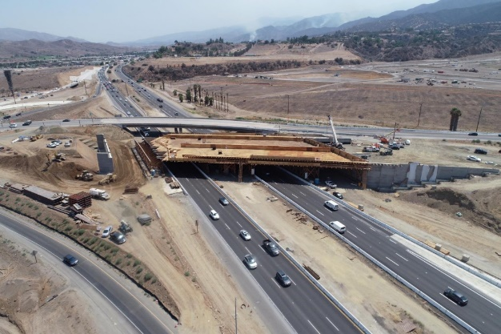
Services included overall construction management, review and manage CM documents, review WSWD and controlling operations, review and analyze CPM Baseline and monthly update schedules, review all RFIs and submittals and responses, assuring timely disposition of correspondences, third-party coordination, review of disputes and potential claims documents, analysis of claims, preparation of claims report for SBCTA management use, negotiation with contractor to resolve claims issues based on the contract document.
After submittal of the proposed final estimate, the contractor submitted $12.5 million exceptions to the proposed final estimate. S2 prepared a thirty-four-page claims report, negotiated the contract, and the claims were finally settled with the contractor for $1.1 million. SBCTA stated that the main reason it was able to resolve this claim at less than 10% of the exceptions amount was because of the detailed analysis performed by S2 staff.

25. FIRMS FROM SECTION C INVOLVED WITH THIS PROJECT
a. | S2 Engineering, Inc. |  | Rancho Cucamonga, CA |  |  | Construction Management / Claims Analyst / Scheduling
STANDARD FORM 330 (REV. 7/2021)

